Bulgaria: first results from home data – on-line job advertisements (OJAs)

Introduction

The analysis is based on the extracted OJAs from the two biggest Internet job-portals in Bulgaria: www.jobs.bg and www.zaplata.bg. The analysis has been carried out taking into accounts the new advertisements published daily in the two Bulgarian job portals for the period May-July 2019. This is the first attempt at analyzing data for OJAs by using Internet portals for advertising job vacancies. Regrettably, the short period does not allow for in-depth study of the trend for vacancies offered at regional level. This could be done at a latter stage as the work in this direction continues and the role and significance of the Big Data for the official statistics could be illustrated through larger empirical material (longer time series).
In order to be methodologically correct, the following facts and assumptions must be taken into account for the purposes of this analysis:
• The traditional JV survey takes account of job vacancies declared by employers at the end of each quarter (according to a European Regulation);
• On-line job vacancy (OJVs) is a different concept from OJAs. Although an OJA may contain 0, 1 or more OJVs, it is assumed for the purposes of this analysis that an OJA contains exactly one OJV. In this case, the two concepts could be used as synonyms.

Methodological consideration: In the future, it is recommended (in order to improve the correctness of the analysis) from the web-scraped data set for OJAs to produce a random sample for the manual, expert verification of how many OJVs contain each OJA included in the sample. Then applying the classical approach to representative, sample surveys, and based on the results obtained, it can be stated with some precision whether the assumption made above is correct or not.

- The total number of monthly OJAs for the period May - July 2019 is calculated from the sum of the daily number of advertisements;
- The average vacancies declared online on the job market in Bulgaria by NUTS 3 for the period of May-July 2019;

The original number of OJAs extracted for the period May - July 2019 from the two sites totaled 195,950. After clearing duplicate records (by comparing all OJAs variables and secondary de-duplication by date, company, city, country and job) 181 059 OJAs records were finally received i.e., 7.6% duplicate records have been deleted.
Obtained data on OJAs by districts of the country offered by the employers show that the largest number is in the districts of Bourgas (4727), Varna (6434), Plovdiv (5654) and Sofia (25462). It can be said that the large number of online vacancies in these areas is logical, given that they contain the largest cities of the country which are industrial and administrative centers. The majority of the country's population is concentrated there compared to the other 24 districts. Some exceptions are observed in Veliko Tarnovo district - 1293 OJVs, Blagoevgrad - 1134, Rousse - 1540 and Stara Zagora - 1577 OJVs. In contrast to the areas mentioned above, a four-digit number for the number of job vacancies in these four areas can also be considered as a temporary phenomenon, since the observed period is too short.
For the correctness of the analytical comparisons by the country districts (NUTS 3), a series of indicators was calculated, as the number of OJAs is related to the number of population, work force, employed and unemployed by the country districts (Table 1).
Table 1:
Number of OJVs and main proportions (in ‰) for the period May - July 2019
 | Monthly Mean (May-July 2019) | Population to Mountly mean | Workforce to Mountly mean | Employed to Mountly mean | Unemployed to Mountly mean
NUTS 3
Blagoevgrad | 1134 | 4 | 6 | 8 | 155
Burgas | 4727 | 12 | 19 | 26 | 468
Dobrich | 726 | 4 | 7 | 10 | 105
Gabrovo | 534 | 5 | 9 | 12 | 254
Haskovo | 682 | 3 | 5 | 7 | 227
Kardzhali | 249 | 2 | 3 | 4 | 119
Kyustendil | 343 | 3 | 5 | 7 | 191
Lovech | 353 | 3 | 5 | 8 | 71
Montana | 251 | 2 | 3 | 6 | 33
Pazardzhik | 948 | 4 | 6 | 9 | 182
Pernik | 503 | 4 | 7 | 10 | 123
Pleven | 949 | 4 | 7 | 10 | 114
Plovdiv | 5654 | 8 | 14 | 19 | 496
Razgrad | 260 | 2 | 4 | 6 | 50
Ruse | 1540 | 7 | 12 | 16 | 291
Shumen | 752 | 4 | 7 | 10 | 77
Silistra | 207 | 2 | 3 | 5 | 40
Sliven | 492 | 3 | 5 | 7 | 63
Smolyan | 164 | 2 | 3 | 3 | 30
Sofia | 677 | 3 | 5 | 6 | 967
Sofia (stolitsa) | 25462 | 19 | 30 | 37 | 1768
Stara Zagora | 1577 | 5 | 9 | 11 | 464
Targovishte | 281 | 3 | 4 | 6 | 49
Varna | 6434 | 14 | 22 | 31 | 677
Veliko Tarnovo | 1293 | 5 | 9 | 13 | 223
Vidin | 199 | 2 | 4 | 7 | 27
Vratsa | 429 | 3 | 5 | 8 | 68
Yambol | 421 | 4 | 6 | 9 | 100
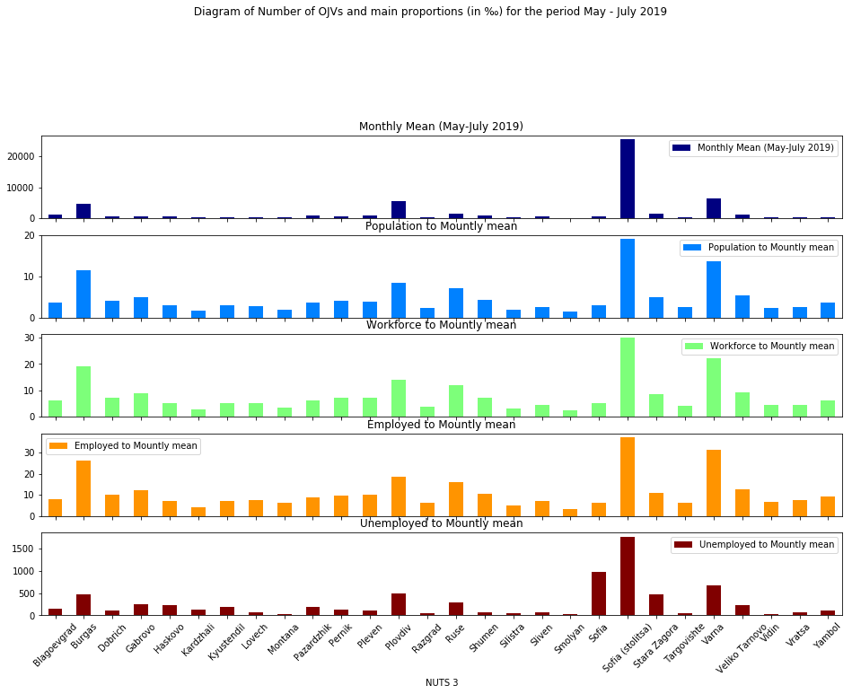

Most interesting is the indicator - OJAs offered per 1000 unemployed people under NUTS3 for the period May-July 2019. For example, there are 1768 OJVs offered to 1000 unemployed people in Sofia – the capital. The high number of job vacancies shows that employers are looking for skilled workers for their businesses. For the other larger districts the same data are as follows per 1000 unemployed: Sofia district - 967; Burgas - 468; Varna - 677; Plovdiv - 496. In regions, where the population is relatively smaller, OJVs per 1 000 unemployed are: Veliko Tarnovo - 223; Gabrovo - 254; Dobrich - 105; Kardzhali - 119; Kyustendil - 191; Pazardzhik - 182; Pernik - 123; Pleven - 114; Haskovo - 227. In the smallest districts, OJVs per 1000 people unemployed are as follows: Shumen - 77; Yambol - 100; Vidin 27; Vratsa - 68; Lovech - 71; Montana - 33; Silistra - 40; Sliven - 63; Smolyan - 30; Targovishte - 49. It should be noted that the population factor (total, working age, employed and unemployed), as a whole, is important, but it is also ranked by a number of other factors and reasons characterizing each of the 28 areas of the country. This means that the geographical position of the district, the communications that have been built, as well as a number of socio-demographic and economic factors that determine the employment potential of the population, respectively for the offered number of online vacancies, are important for the dimension of each indicator.
Another interesting indicator from Table 1 is the ratio of OJVs offered per 1,000 employees. In the districts with the largest cities of the country there is also an increase in the available vacancies per 1000 people employed. For Sofia - the capital these are 37, Plovdiv - 19, Burgas - 26 and Varna - 31 offered OJVs. In other areas of the country, this indicator has relatively lower values. For the period considered, there are few online jobs available per 1000 people employed, which can be explained by the increased demand and job finding, which is the result of the favorable for work summer season. These two indicators are directly relevant to the labor market. In this sense, they characterize and focus on the aggregates of the population that are directly related to OJAs for searcing of labour force.
The data on other ratios between the number of OJVs and the population, respectively relative to the working population in the districts of the country, show smaller values. They reflect in a more generalized way the processes of the labor market, as they are tailored to the size of the districts, and especially to the size of the district cities. This makes them fairly comparable, but with relatively less relevant information on the current situation on the labor market and its changes.
The main conclusion from the data is that, under other things being equal, the demand and supply of job vacancies in the labor market strive for balance. In the larger areas of the country more jobs are offered online. Obviously, the demand and supply are the highest there, but the requirements of the employers are also higher in terms of the skills of workers (see Table 2).

Table 2: Distribution of OJAs by Educational level and NUTS 3
Educational level | Higher | Primary | Secondary
NUTS 3
Blagoevgrad | 117 | 1 | 61
Burgas | 246 | 17 | 217
Dobrich | 41 | 0 | 55
Gabrovo | 56 | 0 | 54
Haskovo | 54 | 1 | 44
Kardzhali | 28 | 0 | 19
Kyustendil | 25 | 0 | 27
Lovech | 46 | 1 | 32
Montana | 29 | 0 | 15
Pazardzhik | 87 | 1 | 80
Pernik | 35 | 2 | 49
Pleven | 80 | 2 | 68
Plovdiv | 493 | 11 | 453
Razgrad | 30 | 0 | 21
Ruse | 144 | 2 | 116
Shumen | 84 | 0 | 59
Silistra | 19 | 0 | 18
Sliven | 43 | 1 | 29
Smolyan | 15 | 0 | 11
Sofia | 63 | 1 | 94
Sofia (stolitsa) | 2259 | 87 | 1662
Stara Zagora | 133 | 2 | 99
Targovishte | 31 | 0 | 18
Varna | 458 | 6 | 368
Veliko Tarnovo | 121 | 1 | 115
Vidin | 13 | 0 | 9
Vratsa | 32 | 0 | 24
Yambol | 37 | 0 | 34

The distribution of the offered OJVs by districts of the country and degrees of education over the observed period indicates that specialists with higher and secondary education are most in demand. This indicates that the innovative approaches to work in most businesses in the country require skilled labor. Obviously, the competition and prosperity of businesses, nationally and internationally, dictates to employers the need to seek and hire individuals with more knowledge and skills. This situation is well expressed in the largest regions of the country: Sofia - the capital, Plovdiv, Varna and Burgas.

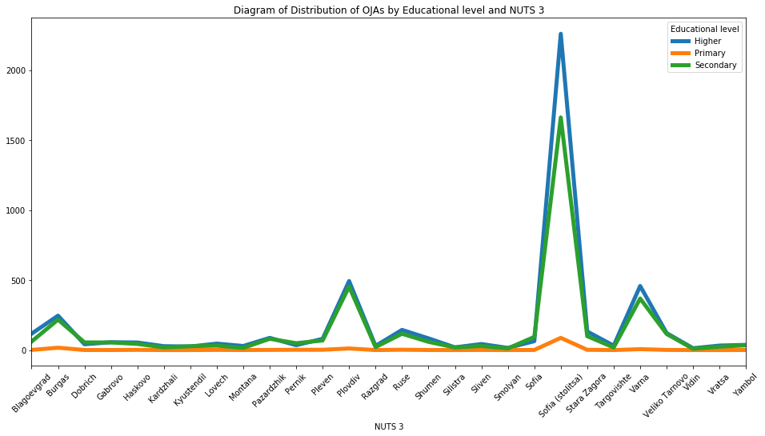

Another feature of OJVs is the type of working time, with 95% of all advertisements being offered at the national level for the May-July 2019 period are for full time jobs.
From the total number of OJAs for the period May-July 2019, for only 70 937 OJAs (or 40% of all) we have found the economic sector of employers offering online job vacancies according to the NACE Rev. 2. This is done by comparing the name of the employer from the advertisement in the job portals to the company name from the statistical business register. In this way, the economic activity from the register was joined to a job advertisement (Table 3).
Table 3: Distribution of OJAs by NUTS 3 and NACE Level 1 for the period May-July 2019

NACE Level 1 | C | D | E | F | G | H | I | J | L | M | N | S
NUTS 3
Blagoevgrad | 94 | 6 | 1 | 25 | 196 | 30 | 147 | 14 | 25 | 28 | 19 | 0
Burgas | 169 | 6 | 3 | 123 | 587 | 70 | 672 | 31 | 92 | 76 | 139 | 2
Dobrich | 86 | 5 | 1 | 15 | 107 | 21 | 72 | 4 | 9 | 11 | 14 | 0
Gabrovo | 88 | 5 | 0 | 8 | 79 | 16 | 17 | 1 | 6 | 2 | 12 | 0
Haskovo | 73 | 2 | 3 | 10 | 110 | 17 | 47 | 1 | 1 | 11 | 14 | 0
Kardzhali | 26 | 2 | 1 | 7 | 24 | 6 | 32 | 2 | 1 | 10 | 5 | 0
Kyustendil | 20 | 3 | 0 | 9 | 39 | 16 | 22 | 2 | 0 | 24 | 9 | 0
Lovech | 65 | 1 | 2 | 3 | 40 | 10 | 20 | 7 | 4 | 3 | 3 | 0
Montana | 27 | 2 | 0 | 5 | 43 | 8 | 34 | 2 | 1 | 7 | 7 | 0
Pazardzhik | 119 | 2 | 6 | 43 | 99 | 46 | 54 | 6 | 6 | 12 | 24 | 0
Pernik | 44 | 7 | 1 | 20 | 65 | 28 | 26 | 5 | 7 | 5 | 24 | 0
Pleven | 143 | 8 | 0 | 30 | 131 | 32 | 49 | 4 | 5 | 12 | 24 | 0
Plovdiv | 538 | 8 | 8 | 136 | 707 | 160 | 312 | 57 | 60 | 131 | 302 | 0
Razgrad | 23 | 4 | 0 | 6 | 35 | 13 | 11 | 5 | 1 | 2 | 3 | 0
Ruse | 219 | 7 | 0 | 17 | 209 | 58 | 84 | 24 | 7 | 18 | 52 | 2
Shumen | 104 | 7 | 2 | 34 | 119 | 22 | 20 | 4 | 6 | 7 | 31 | 1
Silistra | 15 | 2 | 0 | 3 | 49 | 5 | 20 | 5 | 0 | 2 | 1 | 0
Sliven | 54 | 2 | 0 | 10 | 73 | 12 | 41 | 0 | 2 | 6 | 26 | 0
Smolyan | 36 | 0 | 0 | 3 | 22 | 9 | 15 | 3 | 0 | 4 | 5 | 0
Sofia | 124 | 6 | 0 | 9 | 86 | 13 | 14 | 2 | 2 | 7 | 28 | 0
Sofia (stolitsa) | 978 | 47 | 52 | 546 | 2586 | 499 | 1086 | 738 | 243 | 784 | 1069 | 11
Stara Zagora | 139 | 5 | 1 | 59 | 213 | 52 | 109 | 23 | 12 | 21 | 48 | 2
Targovishte | 16 | 4 | 0 | 5 | 43 | 12 | 8 | 4 | 2 | 5 | 4 | 0
Varna | 331 | 20 | 11 | 145 | 886 | 137 | 839 | 80 | 100 | 166 | 206 | 1
Veliko Tarnovo | 165 | 9 | 0 | 17 | 191 | 34 | 110 | 14 | 13 | 22 | 18 | 0
Vidin | 9 | 2 | 0 | 5 | 33 | 9 | 19 | 1 | 0 | 5 | 3 | 0
Vratsa | 43 | 4 | 0 | 32 | 48 | 26 | 10 | 5 | 4 | 10 | 10 | 0
Yambol | 37 | 2 | 0 | 8 | 64 | 10 | 20 | 4 | 2 | 4 | 3 | 0

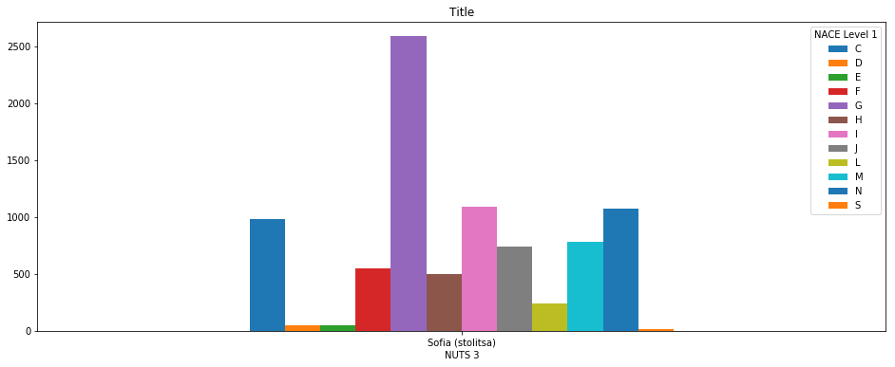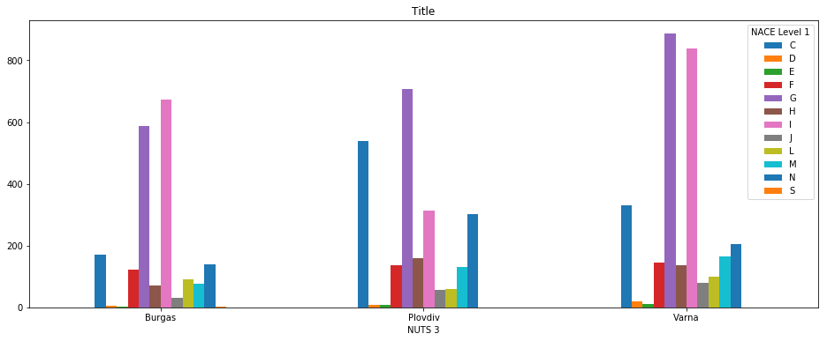

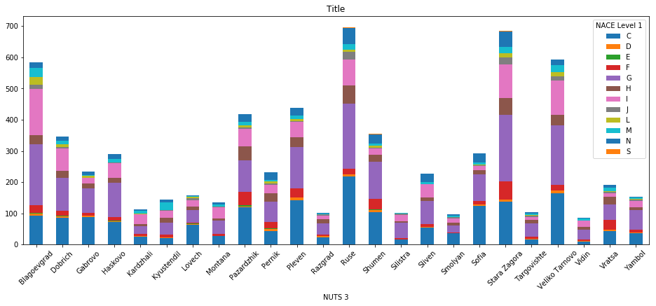

For the list with the statistical indicators described on the WPB wiki confluence page, the graphic presentation of the calculated results is the following:

- Daily number of newly posted OJVs

By NUTS 3

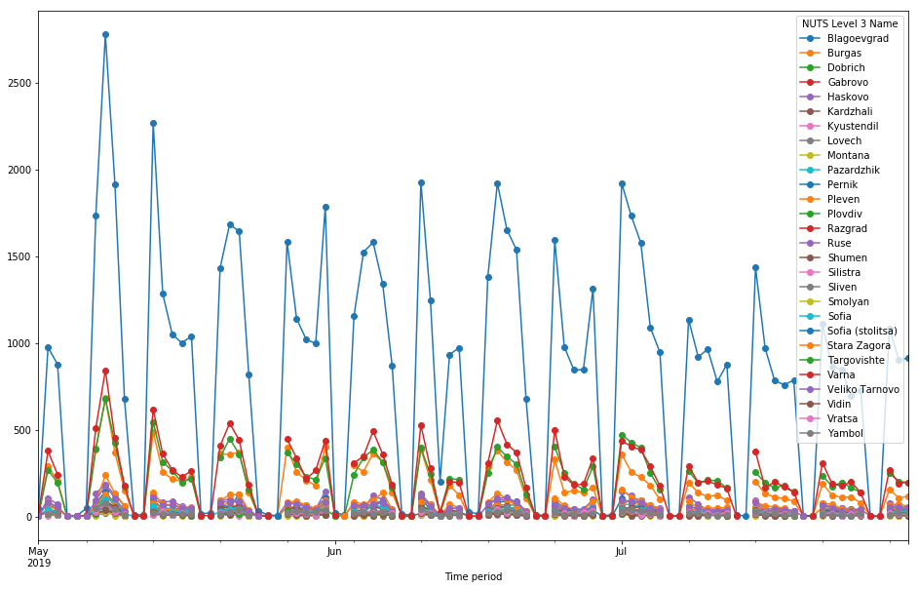
By NACE Level 1:

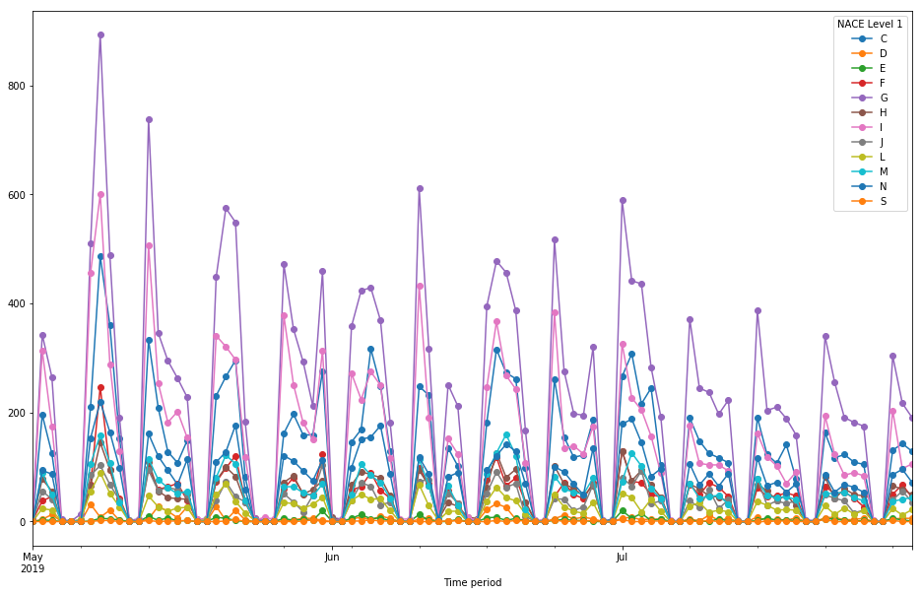

The trends shown in the graphs above present a relatively constant pattern, with the number of daily new advertisements declines in the summer months and particularly in July.
- Daily average newly posted OJVs within month

By NUTS3:

Table 4: Count of OJV advertisements by NUTS Level 3 and time period
Time period | 2019-05 | 2019-06 | 2019-07
NUTS Level 3 Name
Blagoevgrad | 1279 | 1051 | 1073
Burgas | 6174 | 4585 | 3422
Dobrich | 874 | 684 | 619
Gabrovo | 606 | 460 | 537
Haskovo | 715 | 664 | 667
Kardzhali | 300 | 222 | 226
Kyustendil | 338 | 360 | 331
Lovech | 370 | 327 | 361
Montana | 274 | 241 | 237
Pazardzhik | 1023 | 938 | 882
Pernik | 591 | 460 | 458
Pleven | 1098 | 841 | 908
Plovdiv | 6460 | 5271 | 5230
Razgrad | 266 | 261 | 252
Ruse | 1783 | 1381 | 1455
Shumen | 812 | 743 | 701
Silistra | 200 | 210 | 210
Sliven | 527 | 499 | 451
Smolyan | 190 | 155 | 146
Sofia | 768 | 655 | 609
Sofia (stolitsa) | 27912 | 24617 | 23856
Stara Zagora | 1795 | 1452 | 1483
Targovishte | 324 | 276 | 244
Varna | 7661 | 6183 | 5457
Veliko Tarnovo | 1492 | 1231 | 1156
Vidin | 269 | 169 | 158
Vratsa | 464 | 423 | 400
Yambol | 517 | 383 | 364

By NACE Level 1:

Table 5: Count of OJV advertisements by NACE Level 1 and Time period
Time period | 2019-05 | 2019-06 | 2019-07
NACE Level 1
C | 4293 | 3721 | 3487
D | 238 | 168 | 120
E | 92 | 85 | 98
F | 1575 | 1231 | 1326
G | 8158 | 6591 | 6232
H | 1410 | 1374 | 1368
I | 5650 | 4260 | 3126
J | 1171 | 971 | 1014
L | 763 | 672 | 583
M | 1557 | 1478 | 1259
N | 2359 | 2048 | 2064
S | 19 | 22 | 18

Table 6: Count of OJV advertisements by Education Level and Time period
Time period | 2019-05 | 2019-06 | 2019-07
Education Level
Higher | 5476 | 4659 | 4566
Primary | 163 | 150 | 129
Secondary | 4271 | 3890 | 3753

3. The number of on-line job vacancies on the reference day in line with the JVS survey.

It will be further calculated after retrieving data on 30.09. 2019 as reporting day for traditional JV survey.

The population number is relevant for the end of 2019 according to data from the current demographic statistics.
The data are from the survey of the work force for 2019.
The data are from the survey of the work force for 2019.

